Our Idea: [Genius](https://genius.com/) for the Constitution

* Everyone knows how to use Genius and it is very accessible to younger people. We are trying to make the constitution similarly accessible.

Division of Analysis

| Alanah | Alex | Diego | Tobias | Yiqi |
| --- | --- | --- | --- | --- |
| Preamble  Article 2  Article 5  Article 6  Article 7 | Article 3  Amendment 7  Amendment 8  Amendment 9  Amendment 10  Amendment 11  Amendment 12 | Amendment 19  Amendment 20  Amendment 21  Amendment 22  Amendment 23  Amendment 24  Amendment 25  Amendment 26  Amendment 27 | Article 1  Amendment 1  Amendment 2  Amendment 3  Amendment 4  Amendment 5  Amendment 6 | Article 4  Amendment 13  Amendment 14  Amendment 15  Amendment 16  Amendment 17  Amendment 18 |

### Functional and Non Functional Requirements

| **Functional** | **Non Functional** |
| --- | --- |
| Homepage has constitution text | Make it pretty and ccs like |
| Sources page | Chicago Citation Format (because then we can also link to it on homepage with footnotes) |
| Constitution text | On hover: highlight  On click: popup displays to the side of the text (potentially use jQuery UI) |
| Constitution analysis | The popup that shows up on click of constitution text.  Citations link to sources page. |

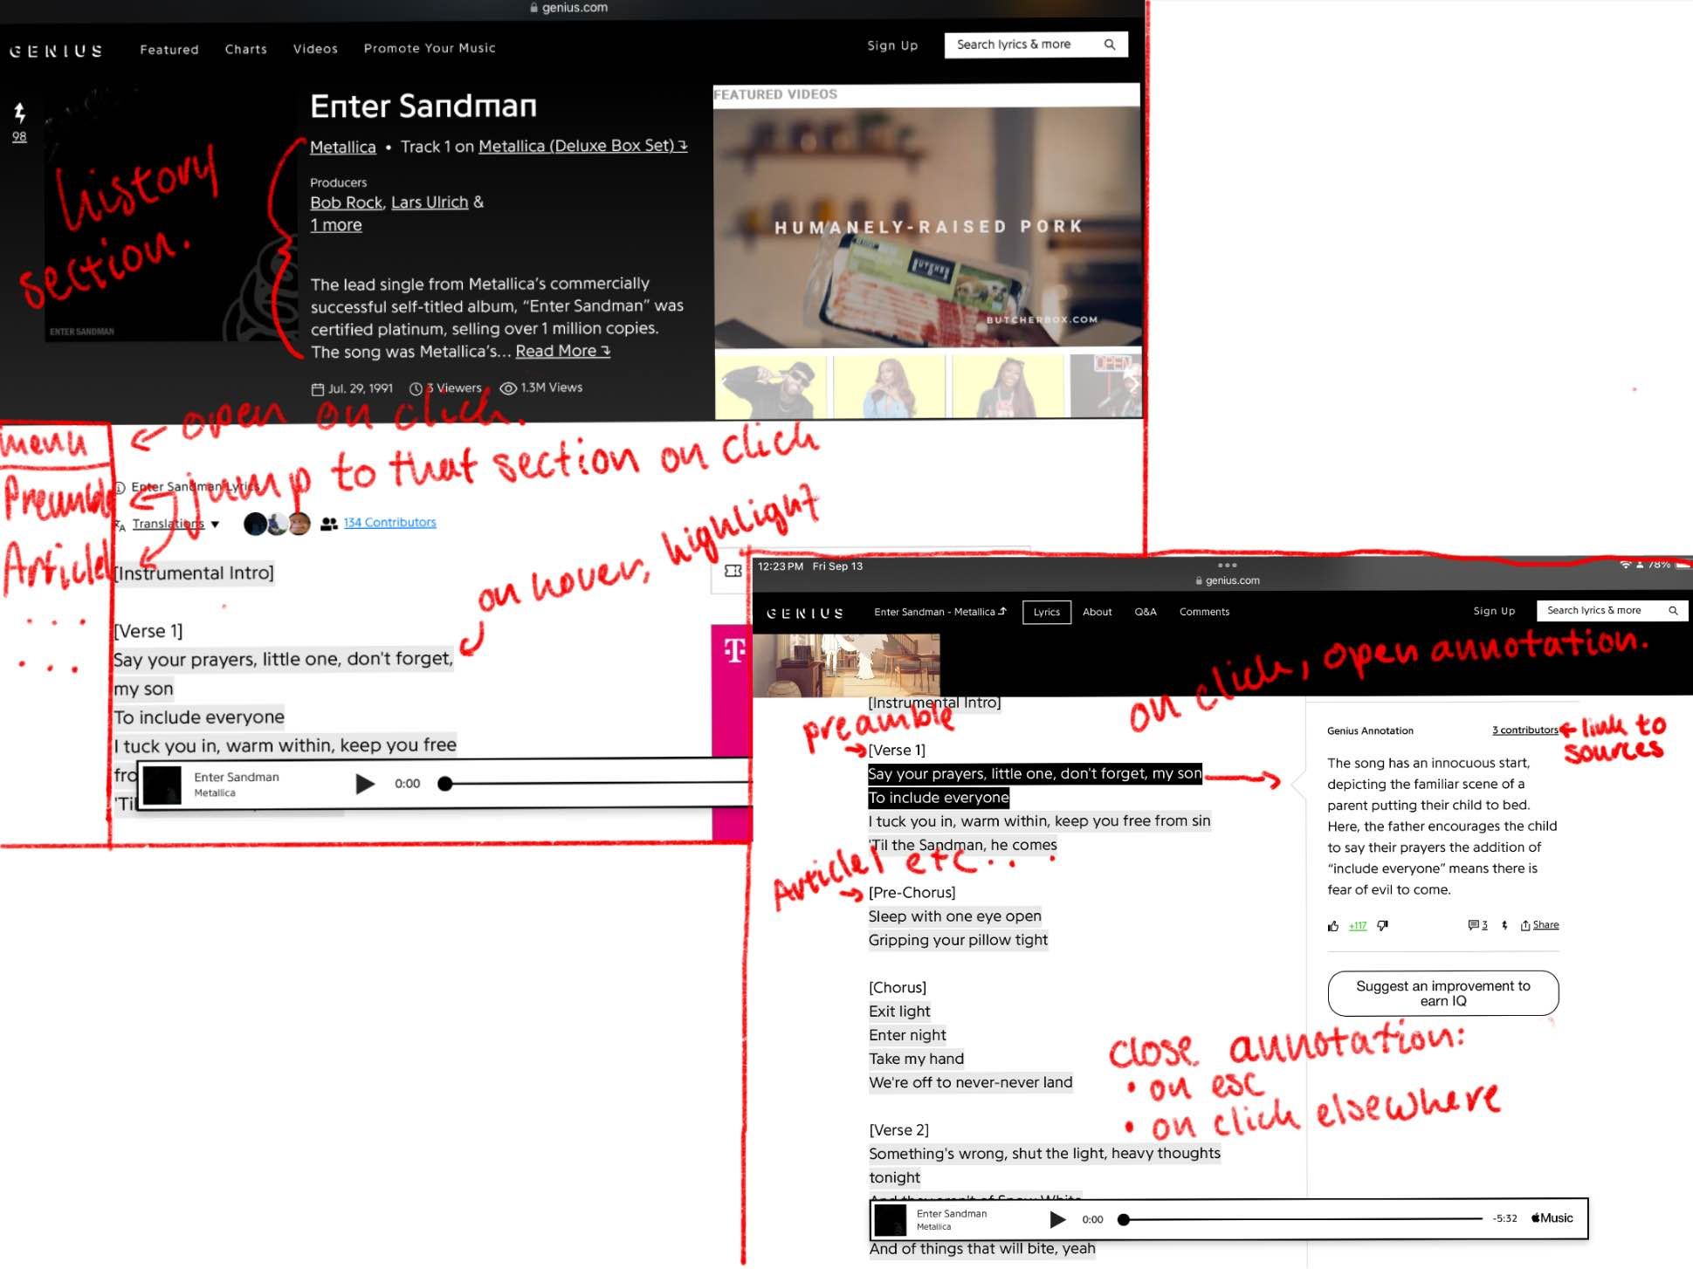

Wireframe drawn by Alex (inspired by Genius):